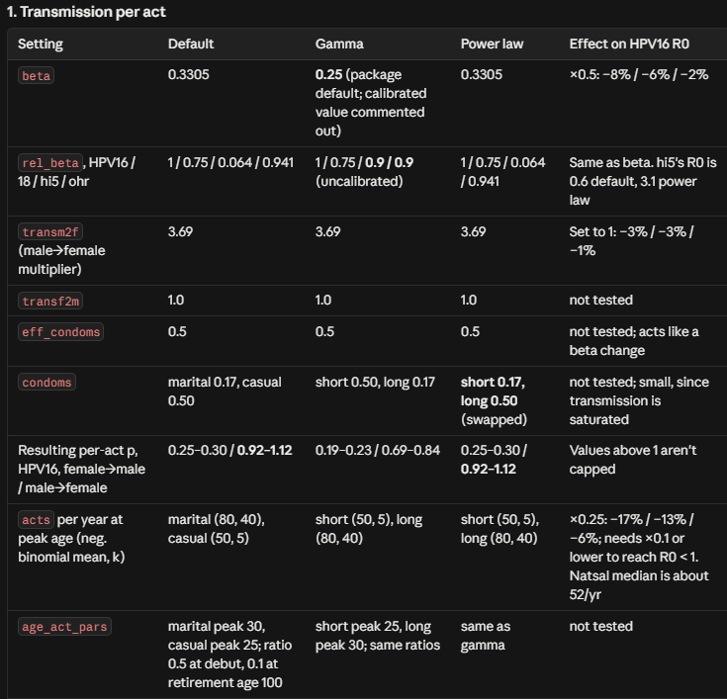

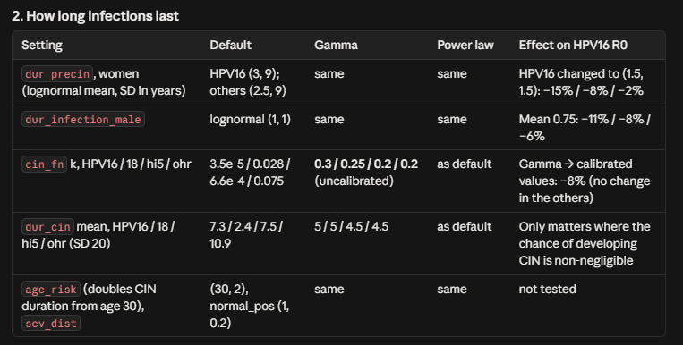
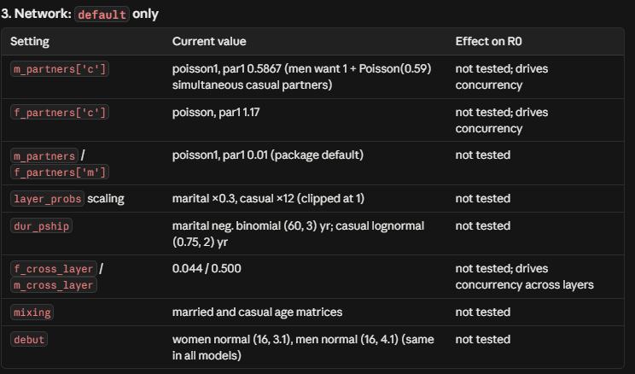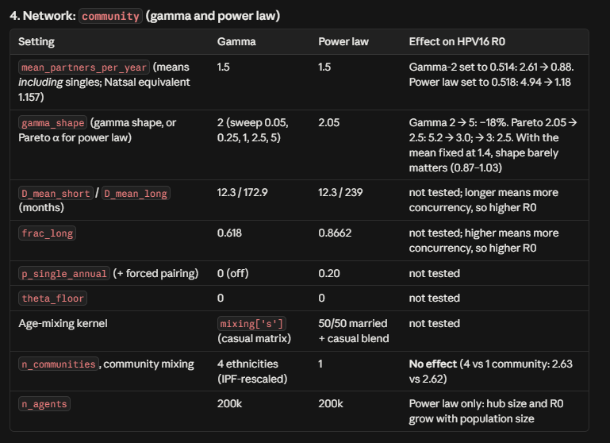
Knobs to change: parameter within distribution (this can chang shape as well as mean partners), acts per year and transmission per act (all to lead to beta per partnership this currently sits near 1), singleness- can add a gate, R0, Mean degrees, concurrency

Burn in doesn’t work as you would want it to?
- How to measure infection? Sim.people.infections.any ?
- Graphs for age structure as well as genotypes
- Power law at 3.5ish, singleness over one year,

